**A Mark Ratings Private Limited**

Address- 1st Floor, Jyoti Cineplex, M.P. Nagar, Zone-1 Bhopal-462011 MP, India

0755-4077839/+91-8770542450

directoramarkratings@gmail.com

[www.amarkrating.com](http://www.amarkrating.com)

AMRPL shall issue a certificate when the client complies with, all the requirements for certification. All certificates issued by AMRPL shall remain the property of AMRPL and must be returned when requested. The certificates are issued for a period of three years and have validity as stated in the certificate. After the issue of the certificate the client is authorized to use the certification mark or the logo in advertising matter in conformity with the following requirements.

**General conditions for use of Logo & Certificates**

**1.0** The client is authorized to use the certification mark or its logo in advertising matter and while using this mark or logo the client shall ensure that it: -

1. Conforms to requirements of AMRPL when making reference to its certification status in communication media such as Internet, brochures or advertising or other documents.
2. Does not make or permit any misleading statement regarding its certification.
3. Does not use or permit the use of the certification document or any part thereof in a misleading manner.
4. Upon suspension or withdrawal of its certification, discontinues its use of all advertising matter that contains a reference to certification, as directed by Conforms to requirements of AMRPL.
5. Amends all advertising matter when the scope of certification has been reduced.
6. Shall not use the certification information in a manner to imply that the product or service is certified. The certification mark or logo shall not be used on a product or product packaging (Outer and Secondary) as this could be interpreted as denoting product conformity.
7. The logos shall also not be applied to laboratory test, calibration or inspection reports or any form of certificates issued by educational institutions as such reports/ certificates are deemed to be products in this context.
8. Does not imply that certification applies to activities that are outside the scope of its certification.
9. Shall not use the certification in such a manner that would bring conforms to requirements of AMRPL and /or the certification system into disrepute and lose public trust.
10. Logo shall not be applied on visiting cards.

**1.1** Whenever the Accreditation Mark is to be used by Conforms to requirements of AMRPL certified clients, it is to be accompanied by the AMRPL logo, & both marks are to be proportioned so that neither has obvious precedence or prominence over the other and its use is limited to stationery, literature and other written promotional materials.

**1.2** The Certification Body / Accreditation Body Logo may be uniformly reduced or enlarged but shall not be less than 15 mm in height and not less than 12mm in width (minimum size15x12mm.), but both the symbols should be legible

**1.3.** The symbols may be reproduced electronically**,** provided that the requirementsof the respective accreditations bodies, as described in this procedure, are met and distortion and /or degradation does not occur

**1.4**. Whenever a subsidiary belonging to a group has been certified there shall not be any confusion as to which part of the group holds the certification and it shall not imply that the other subsidiaries have been certified

**1.5**. Where the organization (the client) wishes to make reference to its certification instead of using the symbols of the certification & accreditation bodies, the organization shall use without variation the phrase “An ISO XXXXX:XXXX Certified Company“ (identify the applicable ISO standard e.g. ISO 9001: 2015

**2.0 Certification body logo**

The AMRPL certification mark may only be reproduced as shown in the attachment-

1 for QMS, 2 for EMS, 3 for OHSMS, 4 for FSMS, 5 for ISMS, 6 for EnMS, 7 for ABMS, 8 for MD-QMS.

**3.0 Accreditation body logo**

The accreditation mark (UAF), shall be reproduced as shown in the attachment-

1 for QMS, 2 for EMS, 3 for OHSMS, 4 for FSMS, 5 for ISMS, 6 for EnMS, 7 for ABMS, 8 for MD-QMS.

**4.0 Misuse**

The misuse of marks or certificate shall result in the following actions.

**4.1** Innocent Misuse

* Immediate withdrawal of the offending literature by the client , or
* Suspension of approval (certification) until misuse is rectified.

If action is not taken to rectify the misuse within a reasonable time, the approval will be withdrawn.

**4.2** **Negligent / Fraudulent misuse**

* Withdrawal of approval together with publication of the reason for withdrawal.

Misuse is deemed negligent / fraudulent where the mark is knowingly or carelessly misused. Repeated “innocent “misuse would be deemed negligent.

**5.0 Withdrawal of certification**

In the event that approval is withdrawn, the client shall immediately cease use and distribution of any literature, stationary etc. bearing the mark. The artwork supplied and all the original approval certificates are to be returned to AMRPL.

**6.0 Contractual Obligation**

**6.1** Correct use of AMRPL certification and the accreditation body mark is a contractual obligation that the client undertakes to comply with as per agreement signed with AMRPL

**6.2** Where the AMRPL certification and accreditation body’s mark has been used by the client, their use is to be reviewed at all surveillance and re-certification audits to ensure that their use is correct and in accordance with the requirements identified in this document.

**6.3** Any misuse of logo shall be brought to the attention of the client and included in the surveillance or the re-certification audit reports.

**6.4** It is likely that in some cases the client may have to update the logos and they still may have stationery and brochures showing the previously issued AMRPL certification and the accreditation body logos. Under such circumstance, it is permissible for the client to continue use of the previously issued logo on the understanding that the new logos must be used in the next printing.

**A Mark Ratings Private Limited**

Director

**Attachment -1**

## AMRPL & UAF LOGO

**ISO 9001: 2015**

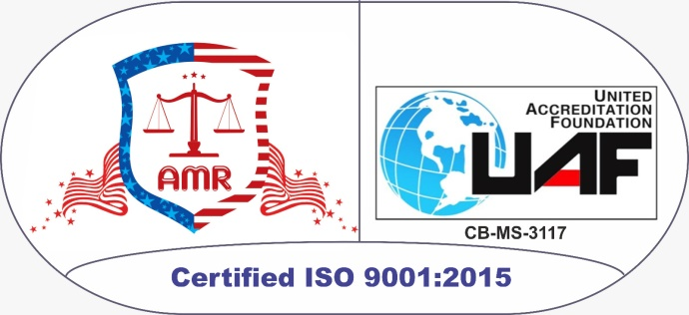

**Attachment -2**

## AMRPL & UAF LOGO

**ISO 14001:2015**

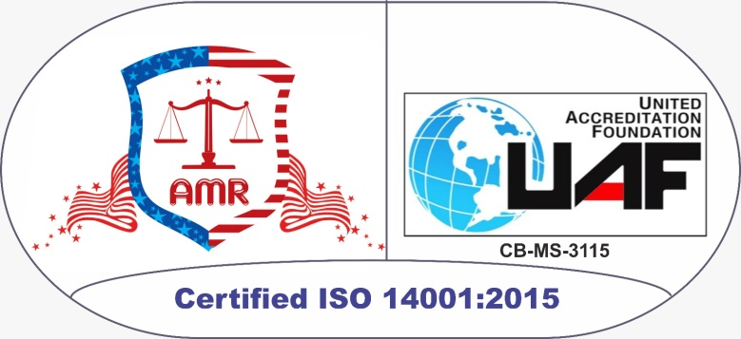

**Attachment -3**

## AMRPL & UAF LOGO

**ISO 45001:2018**

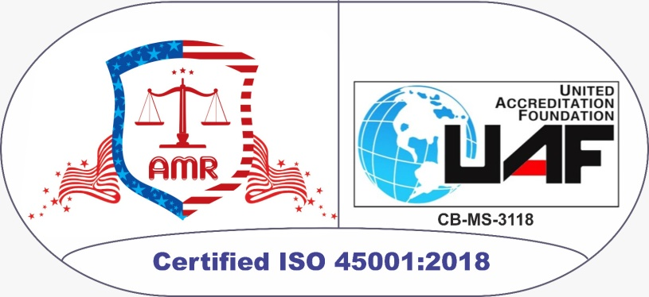

**Attachment -4**

## AMRPL & UAF LOGO

**ISO 22000:2018**

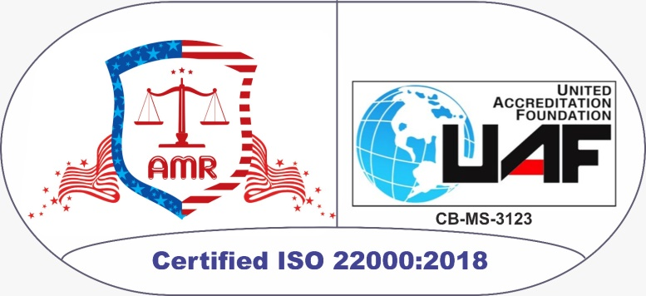

**Attachment -5**

## AMRPL & UAF LOGO

**ISO 27001:2022**

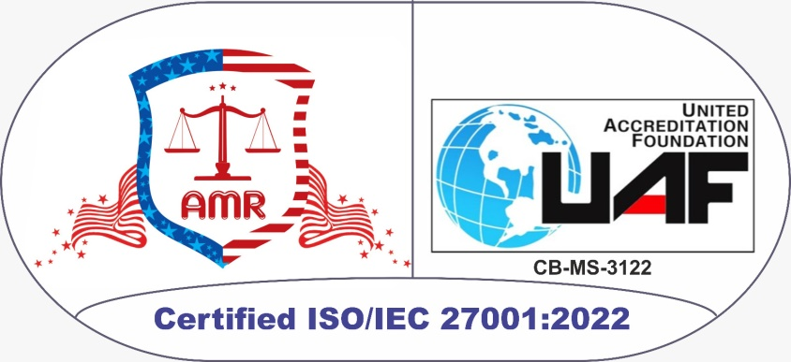

**Attachment -6**

## AMRPL & UAF LOGO

**ISO 50001:2018**

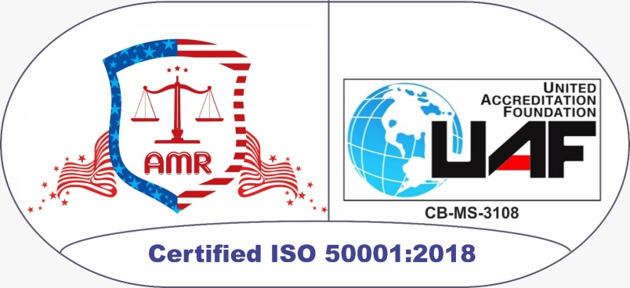

**Attachment -7**

## AMRPL & UAF LOGO

**ISO 37001:2016**

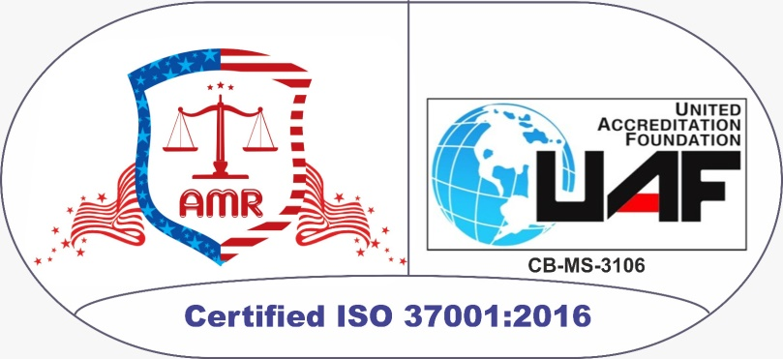

**Attachment -8**

## AMRPL & UAF LOGO

**ISO 13485**

